Tools:

Jacoco test cover analyser setup:

Jacoco tool is necessary to have test coverage analyse available inside sonarqube

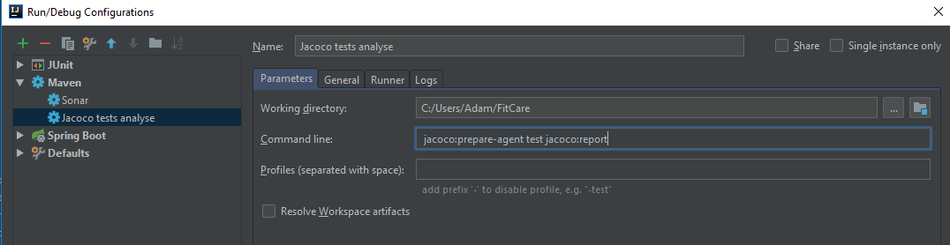

How to run SonarQube localy:

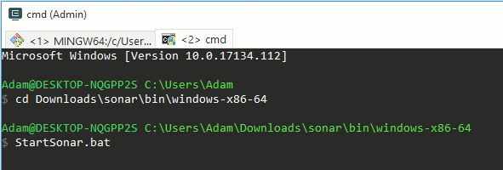

Run SonarQube analyse:

